Technology for Extraction of Isoesters and Solvents from Gas Condensate Fraction

N.T. Kadyrov, T.B. Toraev, Kh.N. Rahimov, Sh. Joraev, M.A. Mirzaahmedova

Department of Chemical Technology of Oil and Gas Processing, Tashkent Institute of Chemical Technology, Navoiy Street 36, Tashkent 100011, Uzbekistan

N.T. Kadyrov,

T.B. Toraev,

N.T. Kadyrovqnuriddin045@gmail.com
This work is devoted to the development and scientific substantiation of a technology for producing organic solvents and isoethers based on raw materials from gas condensate fields in Uzbekistan.
The relevance of the research is explained by the growing demand for high-quality solvents and fuel components in the paint and varnish, petrochemical, metallurgical, and mechanical engineering industries, as well as the need to effectively use local hydrocarbon resources and increase their added value.
The technology of producing isoethers and solvents for the paint and varnish industry from gas condensate fractions is one of the promising and economically effective directions in the chemical industry of deep gas processing. This study investigated the processes for obtaining solvent mixtures based on toluene, xylene isomers, and aliphatic hydrocarbons through deep processing of light and medium fractions of gas condensate. The resulting solvents have been found to be highly effective in dissolving lacquer, paint, resin and polymer materials. The research results serve to expand the possibility of production of value-added chemical products from gas condensate raw materials[1,2].
Key words: gas condensate, lok paint, solvent, octane number, hydrocarbon, isoether, gas chromatography, aromatic hydrocarbons, aliphatic hydrocarbons.
Introduction. Today, solvents are very necessary for many manufacturing enterprises in our republic. In order to meet the demand for solvents in many sectors of the economy, one of the important tasks is to develop and implement simple and effective technologies for their production based on local raw materials. One of the main sources of raw materials for obtaining such solvents is gas condensate.
The demand for solvents used in metallurgical surface cleaning and corrosion protection is increasing year by year, especially in the production of varnishes and metallurgy. In meeting the needs of the national economy for these materials, it is also important to develop the simplest technologies for their extraction and their effective use.
During the scientific research, the results of scientific research on the use of gas condensate as a raw material in various industries and the production of valuable products important for the national economy were analyzed. Technologies for obtaining additives that increase the quality of fuels, as well as solvents that are important for the metallurgical and paint industries, based on the deep processing of gas condensate as a raw material in the chemical industry, have been studied and analyzed.
At the same time, analyses of chemical processes such as obtaining universal and individual, mixed and composite solvents, and isoesters that improve the quality and quantity of fuels through the processing of gas condensate raw materials are presented.
More than 30 enterprises producing lacquer products are operating in our republic. Their annual need for solvents exceeds 150-200 thousand tons. Traditionally, extraction gasoline (63–70 °C fraction) and n-hexane have been used as solvents. The production of these solvents often depends on imported raw materials and technologies[3,4].
In the research work, the process of obtaining alternative solvents that replace the above solvents from a wide fraction of light hydrocarbons - low-sulfur and low-aromatic gas condensate - was studied in order to develop a technology for obtaining gasoline-solvent used in the paint and varnish industry from gas condensate (GC) purified by extraction from aromatic hydrocarbons (AH).
Purpose of the work. The purpose of this work is to analyze the process of producing a high-quality, inexpensive, environmentally friendly and new solvent used in the paint and varnish industry and mechanical engineering by simple and vacuum distillation of gas condensates obtained from local fields, and to study, develop and evaluate the possibilities of industrial application of the technology for obtaining an environmentally friendly and high-quality solvent based on local raw materials that can replace the solvents currently used in the paint and varnish industry imported from abroad.
Research objects and methods. A multi-component hydrocarbon mixture with a wide boiling temperature range — gas condensate — was chosen as the research object. During the research, a number of modern and classical analysis methods were used. Physico-chemical properties of raw materials and products were comprehensively analyzed using gas chromatography, fractional distillation, refractometry, as well as density, viscosity and saturated vapor pressure determination methods.
Experimental part. Gas condensate consists of a mixture of light and colorless hydrocarbons and is a promising raw material for producing high-quality solvents. Light fractions of gas condensate (45–145 °C) are characterized by a low content of aromatic hydrocarbons (0.5–1.5%) and sulfur compounds (0.01–0.025%). This also meets the strict environmental and sanitary-hygienic requirements for solvents used in the food industry [5,6].
In order to extract various solvents from gas condensate by distillation, the physicochemical properties of gas condensate from large gas fields in our republic were studied and analyzed (Table 1).
1-table
Classification of large gas condensate fields in Uzbekistan and physicochemical properties of gas condensates in them
The name of the mine | Annual volume, thousand t/y | Physico-chemical properties |  | Group composition of hydrocarbons, %
The name of the mine | Annual volume, thousand t/y | n_{D}20 | d4²⁰, g/cm³ | Aromatic hydrocarbons | Naphthenic hydrocarbons | Paraffin hydrocarbons
1.Ko’kdumaloq | 2100 | 1,4392 | 0,768 | 12 | 15 | 73
2. Shurtan oil and gas production | 800 | 1,4417 | 0,769 | 29 | 22 | 49
3. MUBORAK | 430 | 1,4777 | 0,731 | 9,3 | 31 | 59,7
4GAZLI | 670 | 1,4464 | 0,773 | 26,2 | 31,7 | 42,1

It was found that the group composition of the gas condensate obtained from the studied fields of the Shurtan Oil and Gas Production Department has a unique characteristic, containing up to 29% aromatic hydrocarbons (AH), up to 49% paraffin hydrocarbons, and up to 26% naphthenic hydrocarbons, which indicates that it is a highly reactive and technologically suitable raw material for the production of organic products.
For several years, specialists and scientists have extracted aliphatic and aromatic solvents from gas condensate and determined their physicochemical, qualitative, and quantitative compositions.
The general physicochemical parameters of gas condensate are as follows: average molecular weight - 164, refractive index - 1.4417, relative density - 0.769 g/cm³. The data presented show that Shurtan gas condensate is the most technologically suitable raw material for obtaining direct distillation products. Such products can be effectively used in further processing processes, including obtaining quality motor fuels and composite solvents.
The most promising and effective methods for obtaining solvents are the separation of gas condensate and its cubic residues by simple distillation, vacuum distillation, or extraction with the help of extractants [7,8].
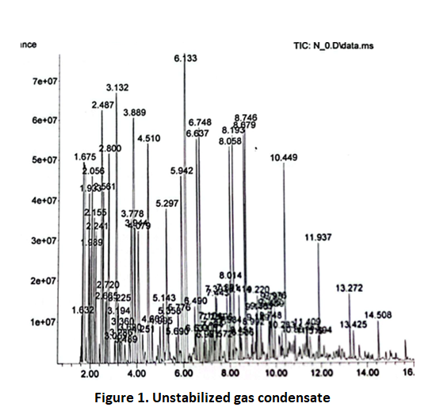
In the work, processes of rectification of gas condensate under atmospheric and vacuum conditions were studied. The results showed that vacuum distillation allows to reduce the thermal decomposition of the components, to increase the selectivity of the separation and to increase the yield of the target products. At the same time, the processes of selective extraction of aromatic hydrocarbons were also studied, and the possibility of forming a composition of solvents with specific properties was identified.
The synthesis of isoesters occupies a special place in the research. They are important as additional components and functional solvents for motor fuels. Etherification reactions were carried out using acid catalysts in the presence of alcohols of different structures and gas condensate fractions. The effect of temperature, time, ratio of reagents and nature of catalyst on the process was studied. The resulting isoethers were found to have high thermal stability, low saturated vapor pressure, and improved physicochemical properties.
In order to achieve accurate results in the research work, residual fractions obtained from low-temperature separation devices on February 3, 2026 from the fields of the Shurtan Oil and Gas Production Department - stabilized and non-stabilized gas condensate samples, as well as cubic residue from the liquefied gas recovery device - were selected for study of the qualitative and quantitative composition.
When initial samples of gas condensate brought for scientific research were analyzed using gas chromatography, the following was revealed.
When comparing the results of gas-chromatographic analysis presented in Figures 1 and 2, it was seen that the amount of light hydrocarbons in the content of unstabilized gas condensate is higher than in the content of stabilized gas condensate. This indicates that the unstabilized gas condensate has a high proportion of light hydrocarbons, which makes it possible to obtain solvents from it, which are important for the paint and varnish industry. Studies have shown that the composition of unstabilized gas condensate (Figure 1) includes hydrocarbons such as 3-methylpentane, hexane, methylcyclopentane, benzene, 3-methylhexane, 1,2-dimethylcyclopentane, heptane, 2,2-dimethylhexane, 2,5-dimethylhexane, 2,4-dimethylhexane, and ethylcyclopentane. They are important raw materials in the production of paints and varnishes in industry.
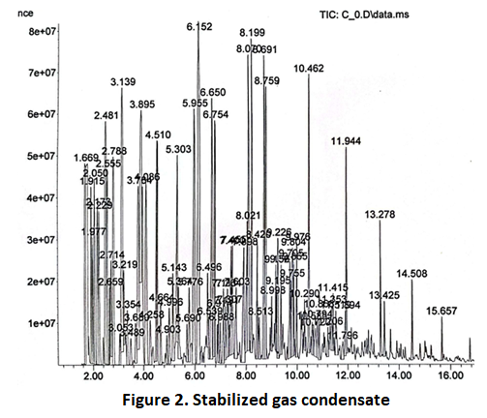
Stabilized gas condensate contains compounds such as dimethyl ether, ethanol, methylhydrazine, 3-methylpentane, n-hexane, benzene, 3-methylhexane, 1,2-dimethylcyclopentane and heptane, which can also be used as raw materials for solvents. However, based on analytical results, it was determined that the proportion of hydrocarbons, which are the main raw materials for solvents, is quantitatively higher in the non-stabilized gas condensate. The percentage of hydrocarbons obtained by normal driving under laboratory conditions was analyzed and the results are presented in Table 3.
Table 3
Fractional composition of gas condensate obtained from the fields of the Shurtan Oil and Gas Production Department by the simple distillation method
Fraction separation temperature, °C | Unstabilized GC,% | Stabilized GC, %
70 °C Light volatile hydrocarbons up to | 1,04 | 0,25
70-100 | 24,53 | 23,87
100-120 | 26,15 | 24,72
120-140 | 21,43 | 22,73
140-160 | 12,28 | 12,35
160-180 | 7,18 | 6,6
180-200 | 4,04 | 6
200-220 | 2,76 | 3,12
220 ° The remainder after C | 0,59 | 0,36

When the unstabilized gas condensate was pumped under normal laboratory conditions, fractions obtained in the range of 70–120 °C were analyzed by gas chromatography. The results showed a high content of light hydrocarbons in the unstabilized gas condensate. This allows for the efficient separation of solvents from this raw material, which are important for the paint and varnish industry. According to the results of simple distillation in laboratory conditions, it was found that up to 75–80% of the fractions separated in the temperature range of 70–120 °C are suitable for use as solvents (Figures 3 and 4).
Unstabilized gas condensate contains a high proportion of light hydrocarbons (alkanes and cycloalkanes in the C₅–C₇ range) with low boiling points. During normal distillation, fractions separated in the range of 70–120 °C are rich in these light components. Since this temperature range corresponds to the boiling points of substances such as hexane, heptane, methylcyclopentane and dimethylcyclopentane, the fraction contains a high percentage of these hydrocarbons.
The results of gas chromatographic analysis show that the fractions separated in the 70–120 °C range contain a high concentration of low molecular weight, non-polar, and highly volatile hydrocarbons.
As we know from our experience, quality solvents are:
• high volatility;
• good dissolution of varnishes and other organic substances;
• to be chemically stable;
• to be ecologically clean;
• It must meet requirements such as a boiling point within the optimal range (usually 60–140 °C)[9,10,11].
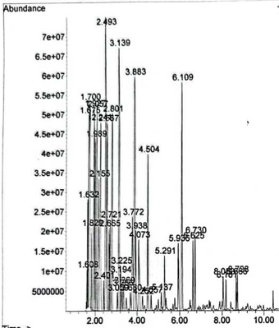 | 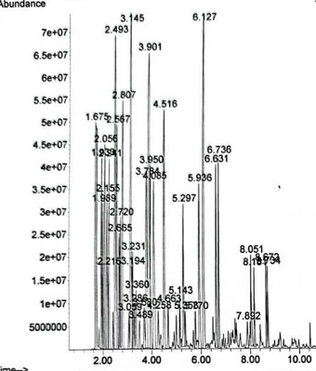
Figure 3. Unstabilized GC was simply heated to 70–100 °C. | Figure 4. Unstabilized GC was simply heated to 100–120 °C.
The fractions obtained as a result of the study in the range of 70–120 °C fully meet these requirements. Their boiling point is technologically suitable and they have fast drying properties. The fraction contains a high proportion of aliphatic and naphthenic hydrocarbons, which dissolve paint components and other organic substances well. The lack of aromatic and sulfur compounds in the composition of the fraction indicates that the product meets environmental and sanitary requirements.
Also, since light fractions are not lost in non-stabilized gas condensate, it is natural that the fraction yield in this range is high (75–80 %). This is the achievement of high efficiency from the point of view of material balance.
The high content of components such as n-xylene, toluene, and ethylbenzene in the gas condensate fractions obtained from the temperature range of 70–120 °C and their physicochemical properties (volatility, non-polarity, and optimal boiling point) justify the use of these fractions as effective organic solvents for the paint and varnish industry. Since the main components of the fraction obtained in this temperature range are volatile and have the property of active solvents in organic media, it was found that these components can be used as solvents in the lacquer industry, in the process of dissolving oils, tars, rubber and some polymers [12,13,14].
Discussion of results. The actual boiling point for hydrocarbon mixtures and their physico-chemical properties depend mainly on the fractionation temperature. Table 4 shows the actual boiling temperatures of the target fraction and the physicochemical properties of the gas condensate of Shortan Oil and Gas Production Department.
The gas condensate was separated into fractions by the method of vacuum driving in a rectification column under laboratory conditions and their actual boiling temperatures were determined. Relative density was measured by pycnometric method, and refractive index was measured by refractometer.
The data in Table 4 show that the actual boiling points for the Shurtan field gas condensate, depending on the fraction separation temperature and their physicochemical properties, vary relatively uniformly over a wide temperature range, that is, without sharp changes. This shows that this raw material has the potential to be used in various industries in obtaining solvents, synthesizing extractants, and obtaining additives that improve the quality of motor fuels.

Table 4.
Actual boiling point and physicochemical properties of gas condensate target fraction of Shurtan Oil and Gas Production Department
Fractional composition | Actual boiling point, °C | nD²⁰ | d4²⁰, г/см³
The onset of boiling point | 333 | 1,4417  ((beginner) | 0,7621  ((beginner)
10% | 360 | 1,4242 | 0,7257
20% | 373 | 1,4280 | 0,7352
30% | 388 | 1,4286 | 0,7523

As the boiling point increases, a target fraction of up to 30% is accumulated in the gas condensate. This fraction corresponds to the properties of azeotropic mixtures of hydrocarbons that boil without separation.
Paint solvent was extracted from this target fraction of gas condensate and its general composition and physicochemical properties were studied (Table 5).
Table 5
Qualitative-quantitative composition and physical-chemical properties of the solvent
The name of the component | amount, % | Boiling temperature °С | Physico-chemical properties
The name of the component | amount, % | Boiling temperature °С | d420 | n_{D}20
Hexane | 40,8 | 68,7 | 0,65 | 1,3748
Heptane | 23,6 | 98,4 | 0,68 | 1,3876
Octane | 19,5 | 125,6 | 0,70 | 1,3974
Other components | 16,0 | 99,2 | 0,69 | 1,3914

The results of the study clearly demonstrated the close relationship between the fractionation temperature and structural properties in the processing of gas condensate. According to gas chromatographic analysis, unstabilized gas condensate contains a high percentage of light hydrocarbons, which confirms that it is a technologically valuable raw material.
When comparing stabilized and non-stabilized gas condensates, it was found that the latter contained a higher amount of alkanes and cycloalkanes in the C₅–C₇ range. This ensures a quantitatively higher yield of fractions that are separated in the range of 70–120 °C during a simple distillation process. This temperature range is explained by the fact that it corresponds to the boiling points of hydrocarbons such as hexane, heptane, methylcyclopentane, and dimethylcyclopentane.
According to the results of fractional analysis, the products separated in the intervals of 70–100 °C and 100–120 °C accounted for the majority of the total yield (approximately more than 50%). This indicates that this fraction can be isolated as a target product in the processing of gas condensate. Experimental results have confirmed that 75–80% of these fractions are suitable for use as solvents [15, 16, ].
From a physicochemical point of view, these fractions have a low molecular weight, high volatility, and non-polar properties, which ensures their good interaction with paint and varnish materials. At the same time, the low content of aromatic hydrocarbons and sulfur compounds increases the environmental safety of the product and its compliance with sanitary requirements.
The results obtained show that it is possible to separate solvent fractions from unstabilized gas condensate with high efficiency using a simple distillation method. The advantages of this process are its technological simplicity, relatively low energy consumption, and high yield.
The results also showed that deep processing of gas condensate allows for the production of not only solvents, but also high-octane fuel components and other petrochemical products. This further strengthens the versatility of the studied raw material and its prospects for widespread use in industry.
Overall, the research results scientifically and practically confirm that it is possible to obtain effective, environmentally friendly, and economically viable solvents for the paint and varnish industry by separating gas condensate into fractions in the range of 70–120 °C. The research proved that hydrocarbon fractions obtained from gas condensate in the temperature range of 70–120 °C are environmentally friendly, harmless solvents for the paint and varnish industry. Its composition was found to consist mainly of hydrocarbons such as hexane, heptane and octane. This solvent can be an alternative to traditional imported solvents in terms of its physico-chemical properties.
The obtained solvent fraction can be used for dilution of lacquer products, degreasing of surfaces, technical cleaning and extraction of organic substances. The high content of light aliphatic and naphthenic hydrocarbons in the composition of the product increases its solubility, and the low content of aromatic and sulfur compounds is an important advantage from the point of view of environmental safety.
The practical importance of the proposed technology is that it allows the use of domestic gas condensate raw materials, reducing dependence on imports and production of competitive solvent products for the republic's industry. The technological simplicity of the simple driving method, relatively low energy consumption and high output of the target fraction are the basis for evaluating this process as an acceptable solution for industrial scale implementation.
Discussion of results. The analysis of the obtained results confirms that the nature of the gas condensate is a mixture of light aliphatic-aromatic hydrocarbons. This mixture, obtained from gas condensate, is characterized by a low sulfur content (0.01–0.025%), a low content of aromatic hydrocarbons (0.5–1.5%), and a high content of paraffin-naphthene fractions. When interpreted from a scientific point of view, the solvents obtained from such gas condensate are a high-purity solvent source, which makes it possible to evaluate them as environmentally friendly and inexpensive raw materials.
The fraction obtained from gas and gas condensate fields of the Shurtan Oil and Gas Production Department in the temperature range of 70–120°C contains hydrocarbons with a non-polar structure, which dissolves organic substances well. The presence of low molecular weight hydrocarbons ensures rapid evaporation of solvents. The lack of aromatic hydrocarbons in the composition of the fraction indicates its low toxicity.
Conclusion. In this research work, the possibilities of obtaining organic solvents for the paint and varnish industry and other sectors based on raw materials from gas condensate fields in our republic were comprehensively studied and scientifically substantiated.
As a result of the conducted studies, the presence of aliphatic, aromatic and naphthenic hydrocarbons in the gas condensate composition showed that it is a highly reactive and technologically desirable raw material. In particular, it was found that Shurtan gas condensate, based on its composition and physicochemical parameters, is a suitable source for obtaining valuable products through direct extraction.
Gas chromatographic analyzes showed a high content of light hydrocarbons in the unstabilized gas condensate. This allows for the efficient separation of solvents important for the paint and varnish industry from this raw material. It was found that up to 75–80% of the fractions obtained from the unstabilized gas condensate at a temperature range of 70–120 °C can be used to obtain solvents and extractants used in various industries.
In general, it has been proven that it is possible to produce inexpensive, high-quality, and environmentally friendly solvents using local gas condensate resources. This will help expand the production of import-substituting products in the republic, provide industrial sectors with local raw materials, and increase economic efficiency.

Used literature
- Содиков У.Х., Жумабоев А.Г., 2019, Получение оксигенатно-углеводородной смеси целевым назначением // Универсум: Технические науки. № 11(68).
- Мурин В.И., Кисленко Н.Н., Сурков Ю.В., 2002, Технология переработки природного газа и конденсата: справочник: в 2 ч. М.: ООО «Недра-Бизнесцентр»,. Ч. 1. 120 с.
- Зайнутдинов С.Б., Алимов А.А., 2004, Исследование состава и свойств газоконденсатов для эффективного извлечения топливных фракций // Узбекский химический журнал.. № 5. С. 31–33.
- Валиев А.А., Алимов А.А., 2004, Физико-химические и эксплуатационные свойства прямогонного бензина, полученного из газоконденсата // Труды научно-технической конференции магистрантов ТХТИ.. С. 78–79.
- Хамидов Б.Н., Самуков Т.И., 2022, Получение смесевых растворителей из газоконденсата // Нефтепереработка и нефтехимия.. № 6. С. 28–30.
- Хамидов Б.Н., Самуков Т.И., 2022, Разработка технологии получения растворителя экстракционного из газоконденсата и исследование его свойств // Мир нефтепродуктов.. № 4. С. 22–24.
- Самуков Т.И., 2022, Экстракция ароматических углеводородов из широких фракций газового конденсата с индивидуальными экстрагентами // Science and Innovation.. № 1. Вып. 7. С. 208–214.
- Исакова А.К., Бобоев Д.С., Тураев Т.Б., . 2023, // Анализ процесса стабилизации свойств газоконденсата. Международной конференции «Инновационные подходы к локализацию» 14 окт, Карши 484-486 б.
- Самуков Т.И., Холтаев Х.Ф., Алимов А.А., 1997, Получение индивидуальных растворителей из газоконденсата // Узбекский журнал нефти и газа.. № 4. С. 48–50.
- Тараканов Г.В., Нурахмедова А.Ф., Попадин Н.В., 2007, Глубокая переработка газовых конденсатов / под ред. Г.В. Тараканова. Астрахань: Факел; ООО «Астраханьгазпром», 276 с.
- Кодиров Н.Т., Жураев Ш., Мураталиева Н.Х., Тураев Т.Б., 2026, Исследование компонентного состава газоконденсатов месторождений шуртан и майманак и перспективы их переработки // Universum: химия и биология электрон. научн. журн. https://7universum.com/ru/nature/archive/item/22380
- Алимов А.А., Самуков Т., Эшмурадов Ш.М., 1997, Коллоидно-химические свойства органодисперсных систем в газоконденсатных растворителях // Узбекский химический журнал.. № 2. С. 21–24.
- Исакова А.К., Бобоев Д.С., Тураев Т.Б., 14 октября 2023, Получение моторных топлив и октаноповышающих добавок к ним из фракции углеводородов газоконденсата // Международная конференция «Инновационные подходы к локализации». Карши. С. 614-615.
- Исакова А.К., Эшонқулов Н.Қ., Жаҳонов Ф.Х., Ахмедова Ф., Тўраев Т.Б., 15–16 июня 2022., Газоконденсатлардан эритувчилар олиш, уларнинг сифат ва миқдор таркибини ишлаб чиқиш // Международная конференция «Современные проблемы экологии и охраны окружающей среды и биотехнологии». Ташкент, С. 1094–1196.
- Jo`raev J, Raximov H, Qodirov N, Utemuratov B, Jabborov A Т, To‘rayev T.B., 2024 , // Gazokondensat va uning yarim mahsulotlaridan kompozitsion erituvchilar olish hamda ularni xossalarini o‘rganish. Kompozitsion materiallar Ilmiy-texnikaviy va amaliy jurnali 174-176 б.
- D.S.Boboev, F.Kh.Jakhonov, A.K.Isakova, N.B.Abdullaev, A.U.Tukhtamushova, Тўраев Т.Б., 2022 , // System solvents based on gas condensate. American Journal of Applied Science and Technology 53-бет.

